Міністерство освіти і науки України

Запорізький національний технічний університет

кафедра програмних засобів

РЕФЕРАТ

з дисципліни: «Якість програмного забезпечення»

на тему: «Software product Quality Requirements and Evaluation»

Виконав:

студент групи КНТ-115 Е. В. Гунько

Перевірила: Г. В. Табунщик

Запоріжжя

2018

# ЗМІСТ

ЗМІСТ 2

1. SOFTWARE PRODUCT QUALITY REQUIREMENTS AND EVALUATION HISTORY BASICS 3

2. CLOSER LOOK AT ISO/IEC 25010 5

3. CONCLUSION 11

СПИСОК ВИКОРИСТАНИХ ДЖЕРЕЛ 12

# SOFTWARE PRODUCT QUALITY REQUIREMENTS AND EVALUATION HISTORY BASICS

ISO/IEC 9126 Software engineering — Product quality was an international standard for the evaluation of software quality.

ISO/IEC 9126 was issued on December 19, 1991. On June 15, 2001, ISO/IEC 9126:1991 was replaced by ISO/IEC 9126:2001 (four parts 9126-1 to 9126-4).

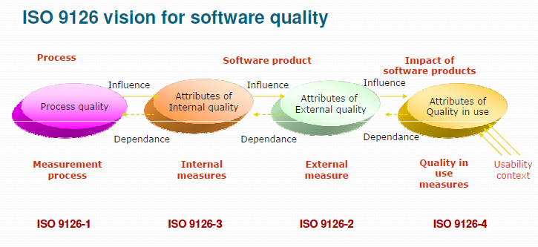

The fundamental objective of the ISO/IEC 9126 standard is to address some of the well known human biases that can adversely affect the delivery and perception of a software development project. These biases include changing priorities after the start of a project or not having any clear definitions of "success". By clarifying, then agreeing on the project priorities and subsequently converting abstract priorities (compliance) to measurable values (output data can be validated against schema X with zero intervention), ISO/IEC 9126 tries to develop a common understanding of the project's objectives and goals.

The standard is divided into four parts:

* quality model
* external metrics
* internal metrics
* quality in use metrics.

ISO/IEC then started work on SQuaRE (Software product Quality Requirements and Evaluation), a more extensive series of standards to replace ISO/IEC 9126, with numbers of the form ISO/IEC 250mn. For instance, ISO/IEC 25000 was issued in 2005, and ISO/IEC 25010, which supersedes ISO/IEC 9126-1, was issued in March 2011. ISO 25010 has eight product quality characteristics (in contrast to ISO 9126's six), and 31 subcharacteristics.

On March 1, 2011, ISO/IEC 9126 was replaced by ISO/IEC 25010:2011 Systems and software engineering - Systems and software Quality Requirements and Evaluation (SQuaRE) - System and software quality models. Compared to 9126, "security" and "compatibility" were added as main characteristics.

What changed?

* "Functionality" is renamed "functional suitability". "Functional completeness" is added as a subcharacteristic, and "interoperability" and "security" are moved elsewhere. "Accuracy" is renamed "functional correctness", and "suitability" is renamed "functional appropriateness".
* "Efficiency" is renamed "performance efficiency". "Capacity" is added as a subcharactersitic.
* "Compatibility" is a new characteristic, with "co-existence" moved from "portability" and "interoperability" moved from "functionality".
* "Usability" has new subcharacteristics of "user error protection" and "accessibility" (use by people with a wide range of characteristics). "Understandability" is renamed "appropriateness recognizability", and "attractiveness" is renamed "user interface aesthetics".
* "Reliability" has a new subcharacteristic of "availability" (when required for use).
* "Security" is a new characteristic with subcharacteristics of "confidentiality" (data accessible only by those authorized), "integrity" (protection from unauthorized modification), "non-repudiation" (actions can be proven to have taken place), "accountability" (actions can be traced to who did them), and "authenticity" (identity can be proved to be the one claimed).
* "Maintainability" has new subcharacteristics of "modularity" (changes in one component have a minimal impact on others) and "reusability"; "changeability" and "stability" are rolled up into "modifiability".
* "Portability" has "co-existence" moved elsewhere.

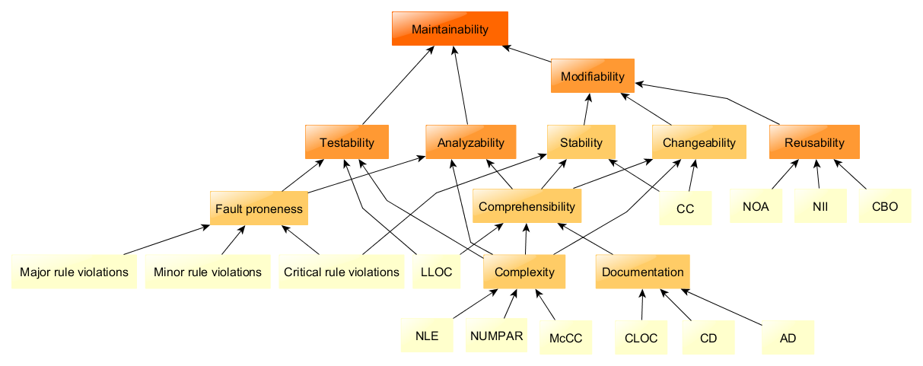

# CLOSER LOOK AT ISO/IEC 25010

The quality model is the cornerstone of a product quality evaluation system. The quality model determines which quality characteristics will be taken into account when evaluating the properties of a software product.

The quality of a system is the degree to which the system satisfies the stated and implied needs of its various stakeholders, and thus provides value. Those stakeholders' needs (functionality, performance, security, maintainability, etc.) are precisely what is represented in the quality model, which categorizes the product quality into characteristics and sub-characteristics.

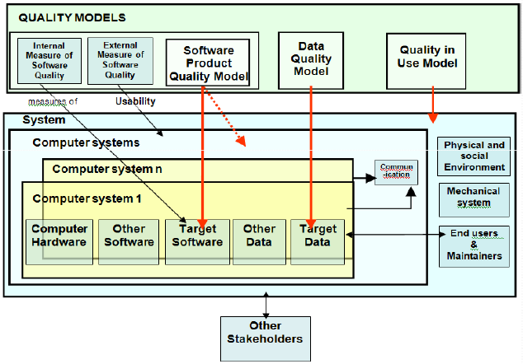

The product quality model defined in ISO/IEC 25010 comprises the eight quality characteristics shown in the following figure:

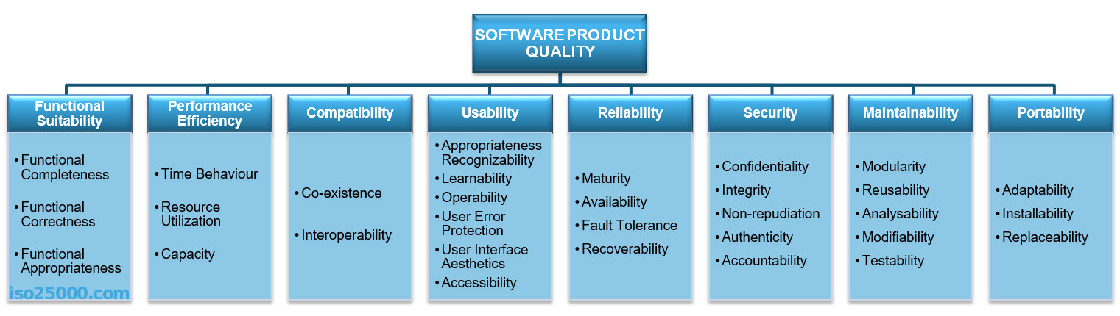

Functional Suitability

This characteristic represents the degree to which a product or system provides functions that meet stated and implied needs when used under specified conditions. This characteristic is composed of the following subcharacteristics:

* Functional completeness. Degree to which the set of functions covers all the specified tasks and user objectives.
* Functional correctness. Degree to which a product or system provides the correct results with the needed degree of precision.
* Functional appropriateness. Degree to which the functions facilitate the accomplishment of specified tasks and objectives.

Portability

Degree of effectiveness and efficiency with which a system, product or component can be transferred from one hardware, software or other operational or usage environment to another. This characteristic is composed of the following subcharacteristics:

* Adaptability. Degree to which a product or system can effectively and efficiently be adapted for different or evolving hardware, software or other operational or usage environments.
* Installability. Degree of effectiveness and efficiency with which a product or system can be successfully installed and/or uninstalled in a specified environment.
* Replaceability. Degree to which a product can replace another specified software product for the same purpose in the same environment.

Maintainability

This characteristic represents the degree of effectiveness and efficiency with which a product or system can be modified to improve it, correct it or adapt it to changes in environment, and in requirements. This characteristic is composed of the following subcharacteristics:

* Modularity. Degree to which a system or computer program is composed of discrete components such that a change to one component has minimal impact on other components.
* Reusability. Degree to which an asset can be used in more than one system, or in building other assets.
* Analysability. Degree of effectiveness and efficiency with which it is possible to assess the impact on a product or system of an intended change to one or more of its parts, or to diagnose a product for deficiencies or causes of failures, or to identify parts to be modified.
* Modifiability. Degree to which a product or system can be effectively and efficiently modified without introducing defects or degrading existing product quality.
* Testability. Degree of effectiveness and efficiency with which test criteria can be established for a system, product or component and tests can be performed to determine whether those criteria have been met.

Security

Degree to which a product or system protects information and data so that persons or other products or systems have the degree of data access appropriate to their types and levels of authorization. This characteristic is composed of the following subcharacteristics:

* Confidentiality. Degree to which a product or system ensures that data are accessible only to those authorized to have access.
* Integrity. Degree to which a system, product or component prevents unauthorized access to, or modification of, computer programs or data.
* Non-repudiation. degree to which actions or events can be proven to have taken place, so that the events or actions cannot be repudiated later.
* Accountability. Degree to which the actions of an entity can be traced uniquely to the entity.
* Authenticity. Degree to which the identity of a subject or resource can be proved to be the one claimed.

Reliability

Degree to which a system, product or component performs specified functions under specified conditions for a specified period of time. This characteristic is composed of the following subcharacteristics:

* Maturity. Degree to which a system, product or component meets needs for reliability under normal operation.
* Availability. Degree to which a system, product or component is operational and accessible when required for use.
* Fault tolerance. Degree to which a system, product or component operates as intended despite the presence of hardware or software faults.
* Recoverability. Degree to which, in the event of an interruption or a failure, a product or system can recover the data directly affected and re-establish the desired state of the system.

Usability

Degree to which a product or system can be used by specified users to achieve specified goals with effectiveness, efficiency and satisfaction in a specified context of use. This characteristic is composed of the following subcharacteristics:

* Appropriateness recognizability. Degree to which users can recognize whether a product or system is appropriate for their needs.
* Learnability. degree to which a product or system can be used by specified users to achieve specified goals of learning to use the product or system with effectiveness, efficiency, freedom from risk and satisfaction in a specified context of use.
* Operability. Degree to which a product or system has attributes that make it easy to operate and control.
* User error protection. Degree to which a system protects users against making errors.
* User interface aesthetics. Degree to which a user interface enables pleasing and satisfying interaction for the user.
* Accessibility. Degree to which a product or system can be used by people with the widest range of characteristics and capabilities to achieve a specified goal in a specified context of use.

Compatibility

Degree to which a product, system or component can exchange information with other products, systems or components, and/or perform its required functions, while sharing the same hardware or software environment. This characteristic is composed of the following subcharacteristics:

* Co-existence. Degree to which a product can perform its required functions efficiently while sharing a common environment and resources with other products, without detrimental impact on any other product.
* Interoperability. Degree to which two or more systems, products or components can exchange information and use the information that has been exchanged.

Performance efficiency

This characteristic represents the performance relative to the amount of resources used under stated conditions. This characteristic is composed of the following subcharacteristics:

* Time behaviour. Degree to which the response and processing times and throughput rates of a product or system, when performing its functions, meet requirements.
* Resource utilization. Degree to which the amounts and types of resources used by a product or system, when performing its functions, meet requirements.
* Capacity. Degree to which the maximum limits of a product or system parameter meet requirements.

# CONCLUSION

ISO 25010 model is somewhat different from ISO 9126 model:

* Relations between system and software in the new model

with introduction of the data model (ISO 25012)

* Quality in use has 5 characteristics instead of 4 without

productivity and compliance but adding efficiency,

satisfaction and usability

* Integration of internal and external characteristics and sub

characteristics with 2 new characteristics: security and

compatibility

* From there new attributes should be added
* Data quality model characteristics are not a part of 25021

# СПИСОК ВИКОРИСТАНИХ ДЖЕРЕЛ

1. ISO/IEC 25010 [Електронний ресурс]. – Режим доступу: <https://iso25000.com/index.php/en/iso-25000-standards/iso-25010>.
2. Інженерія якості програмного забезпечення:навчальний посібник / Г.В Табунщик, Р.К. Кудерметов, Т.І. Брагіна. – Запоріжжя: ЗНТУ, 2013. – 180 с.
3. ISO/IEC 9126 [Електронний ресурс]. – Режим доступу: <https://en.wikipedia.org/wiki/ISO/IEC_9126>.
4. ISO/IEC 9126 and ISO/IEC 25010 comparison [Електронний ресурс]. – Режим доступу: http://www.itest.pro/wp-content/uploads/2013/08/9126-vs-25010.pdf